Darren Henry MP
Broxtowe Senior Citizens’ Fair

- A wide range of stalls and exhibitors from a variety of sectors
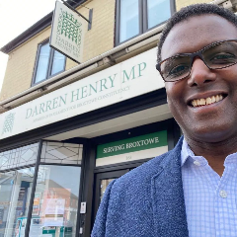
- Learn more about how Darren can help you
- Free advice and information on travel, finances,
health and safety

Come along, have fun and enjoy free tea,
coffee and biscuits with us!

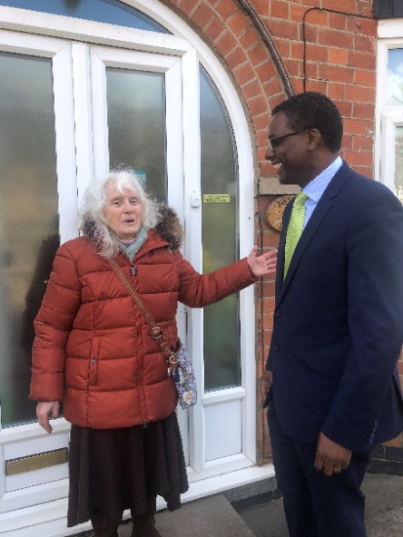
Includes:

- DWP Help and Advice on Pension Credit
- Hobbies/groups
- Charities
- Medical support
- Local services
FREE Tea, Coffee and biscuits
- Financial advice
- Transport
- Keeping safe
- Enhancing lifestyle
- Help & advice
- Part-time and volunteering opportunities

FREE EVENT

Thursday 16th May 2024 10am – 1pm
Beeston Ex-Servicemens Victory Club
75 Station Rd, Beeston, Nottingham NG9 2AW

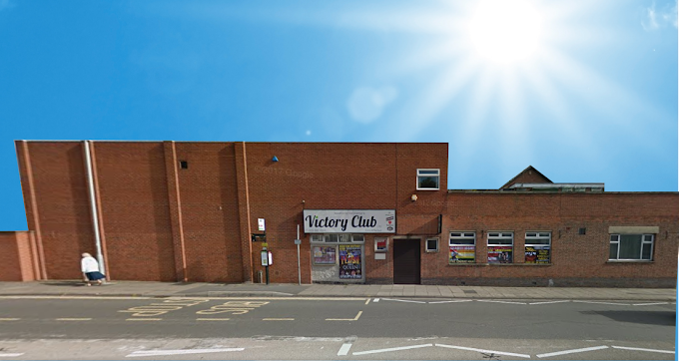
For more information:

t: 0115 671 2530
w: www.darrenhenrymp.org.uk
e: Darren.henry.mp@parliament.uk

Darren HENRY MP – Serving Broxtowe

